**_Expertbells**

1. Video will be played automatically-----------------------Done
2. Connect with mentor section image----------------------------------Done

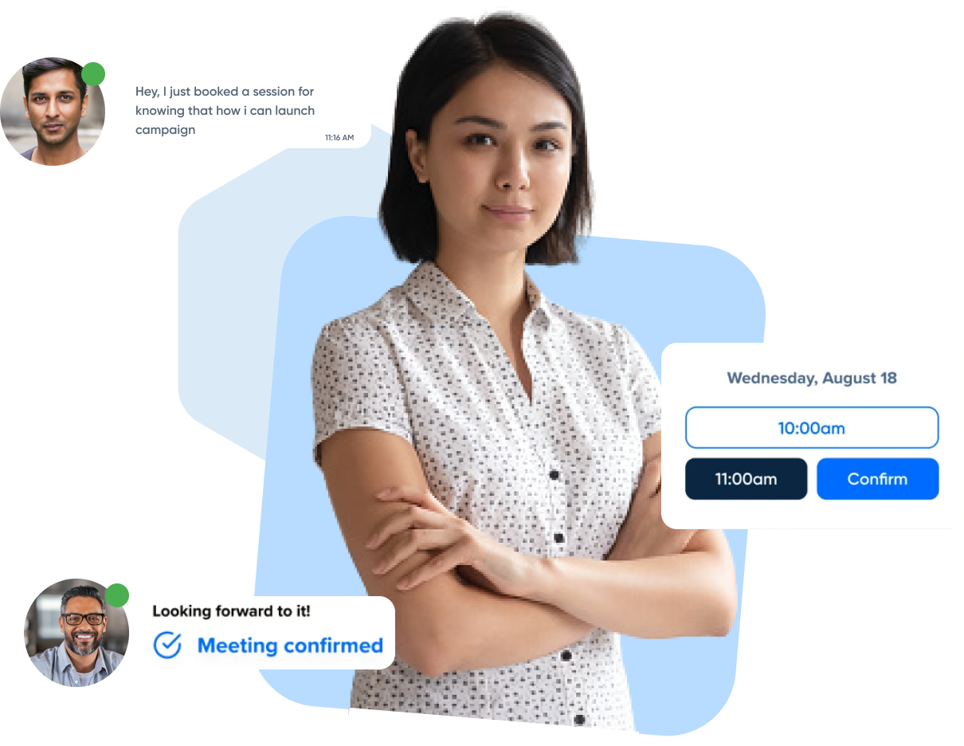

1. Choose your experts section design:---------------------------------------------------Done

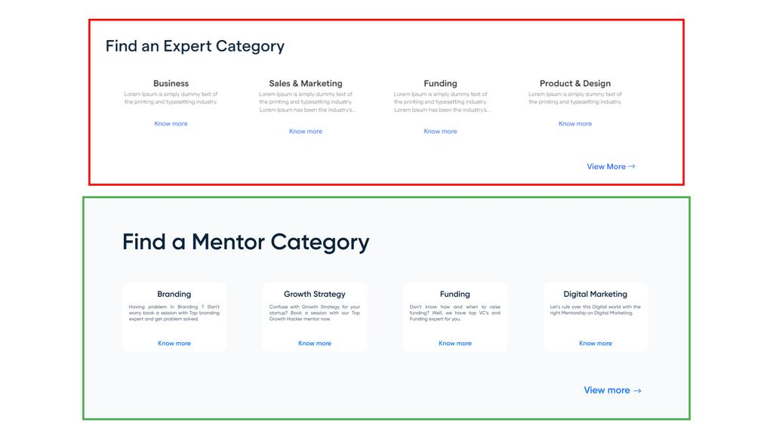

1. Experts listing card expertise showing brackets, remove it.------------------------------------Done
2. After name, Designation/Role will be coming with company name after a comma------------------Done

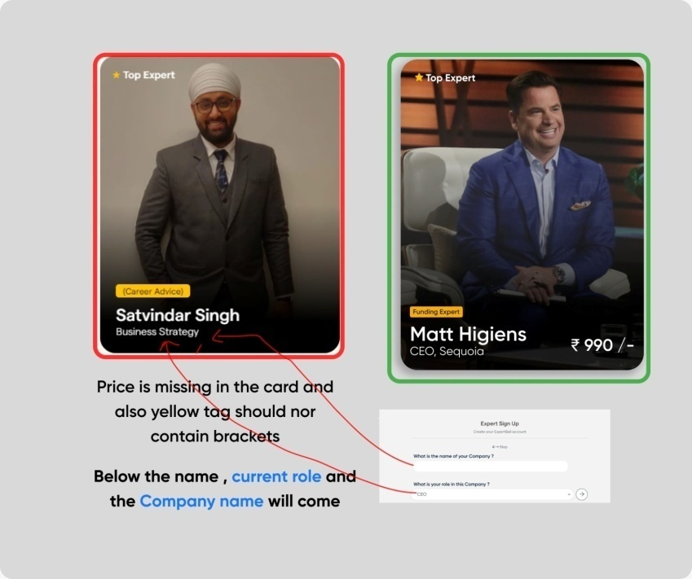

1. Price also missing---------------------------------------------------Done
2. Expertise, role and industries basis filter option. Expert listing page.---------------------Done
3. Expert details page: expert details, add industries as well.--------------------------------------------Done

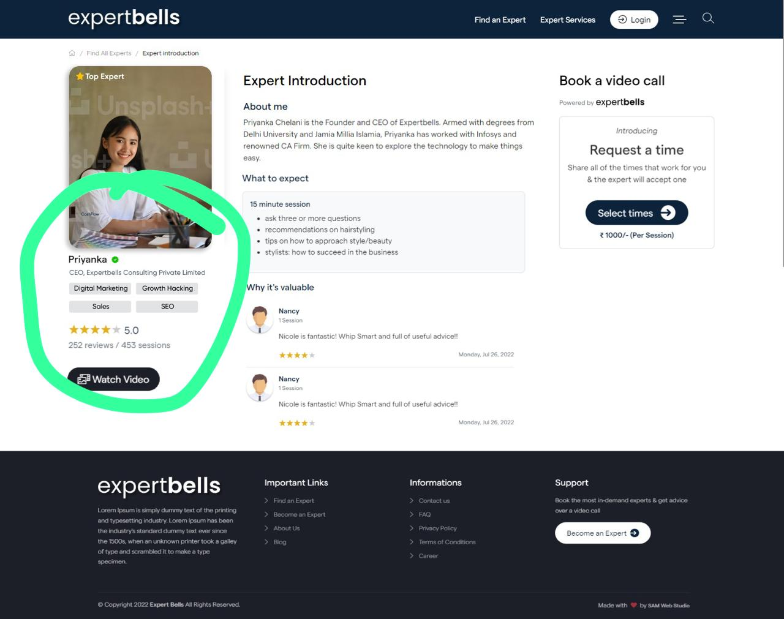

1. 15 minute slots will be removed; 30 – 60 options will be there only.-----------------------Done
2. Date picker for user while booking the slot, inactive dates and past and future month dates will be a bit dark.----------------------------------------------Done
3. Thank you page, will have fixed questionnaire which was provide by client. Skip option will be there too, but it will keep on showing on the dashboard with the booking which was not filled by the user. Expert will only see what they’ve filled. This will be shown in the user’s account.

Skip and continue icon is not working.

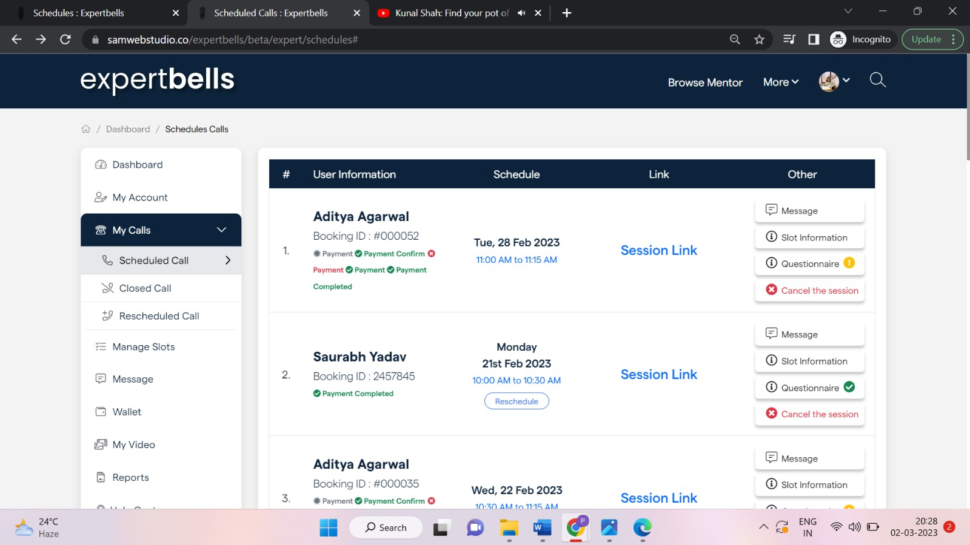

1. User scheduled calls page will also be shown as experts.----------------------------🡪Done
2. Call reschedule option will be deactivated before 8 hours of call time.-----------------------------Done
3. Message box will look like a chat, remove to and subject from it. ----------------------------------🡪Done
4. Wallet and online payment option needs to be checked.
5. Weekly schedule design needs to be applied on the new.
6. GUI designing of video call interface will be either like Google meet or growth mentor.

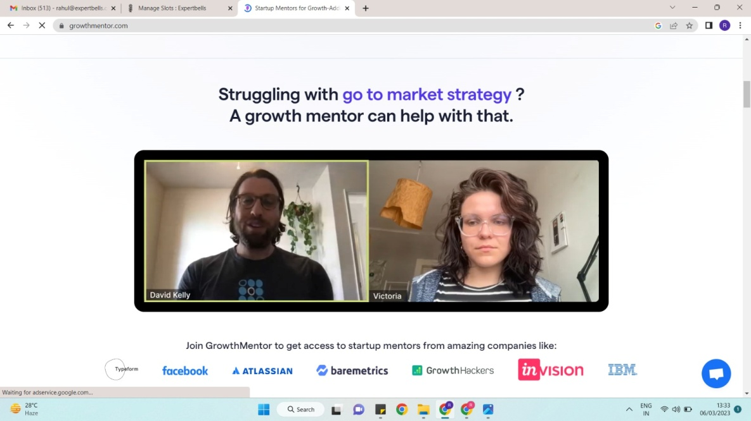

1. More drop down options are not linked.
2. Podcast and ebooks will be hidden for now.
3. Expertbells.com will be new site, old expertbells website for CA services will be under a directory “Service”. So that the service page URLs of the old website should remain as it is.
4. Genuine expert profiles will be with genuine names. No stupid names will be used for testing.
5. Become an expert process, Will be as the PDF shared Step-1 (1) (1).pdf 6th step will be as screenshot provided.--------------------Done
6. Video player before playing showing a line, remove it.
7. New video provided.